**DAILY ONLINE ACTIVITIES SUMMARY**

|  |  |  |  |  |  |  |  |  |
| --- | --- | --- | --- | --- | --- | --- | --- | --- |
| **Date:** | **11-06-2020** | | | | | **Name:** | **Ashwini** | |
| **Sem & Sec** | **A** | | | | | **USN:** | **4AL17CS017** | |
| **Online Test Summary** | | | | | | | | |
| **Subject** | | **Python** | | | | | | |
| **Max. Marks** | | **20** | | **Score** | | | **13** | |
| **Certification Course Summary** | | | | | | | | |
| **Course** | **INTRODUCTION TO ETHICAL HACKING** | | | | | | | |
| **Certificate Provider** | | | Greatlearning  Academy | | **Duration** | | | 6hours |
| **Coding Challenges** | | | | | | | | |
| **Status: Done** | | | | | | | | |
| **Uploaded the report in Github** | | | | | **YES** | | | |
| **If yes Repository name** | | | | | <https://github.com/ashwiniachar/online-report> | | | |
| **Uploaded the report in slack** | | | | | **YES** | | | |

Online Test Details:

Subject:-CGV.

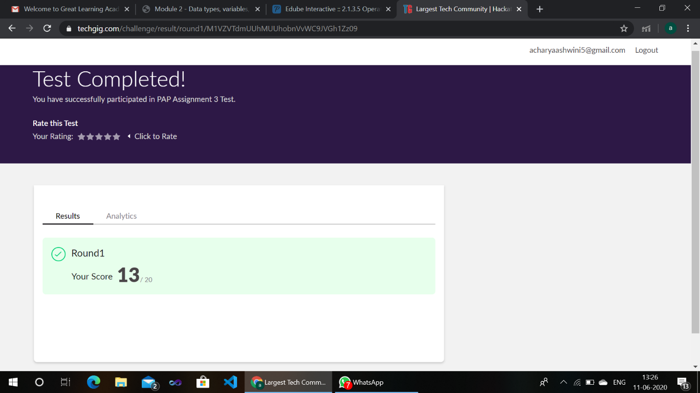CERTIFICATION COURSE:

**Introduction to Ethical Hacking:**

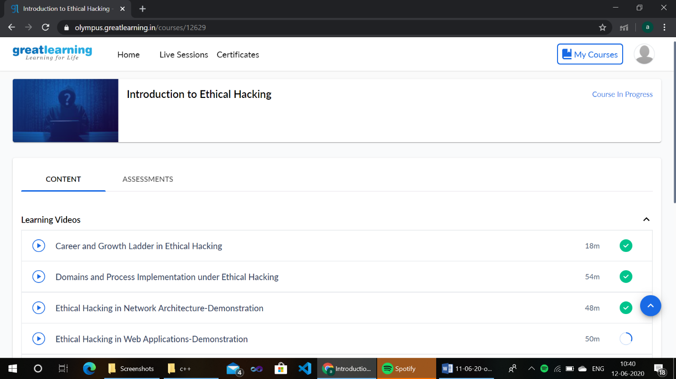

**Coding Challenges Details:**

1) 